 Safety Data Sheet Safety Data Sheet
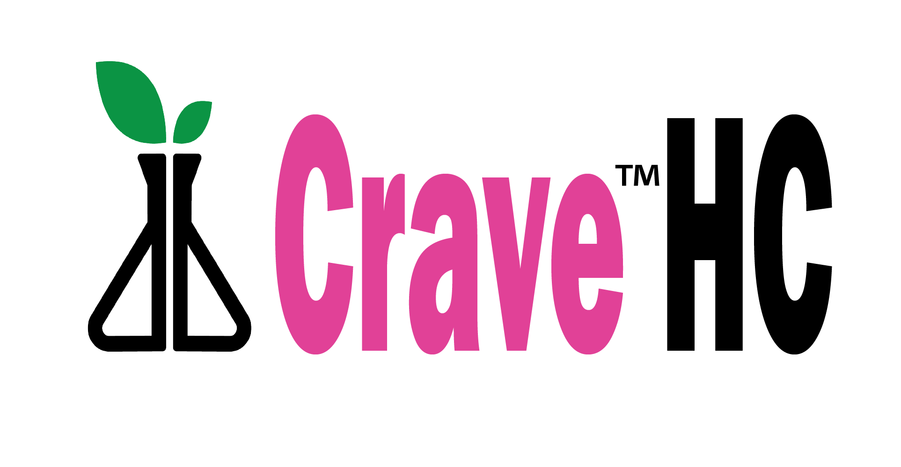
Issue Date: 09-23-2026 v.1
- Identification
  - Product Identifier
Product form Liquid
Product Name Crave HC
1.2 Identified Uses
Recommended Use Seed, Plant, or Soil Amendment
1.3 Supplier of the SDS
Dakota Bio
102 E Bailie St
Kentland, IN 47951
Tel. 833-325-6822
Email info@dakotabio.com

- Hazards Identification
2.1 Classification of the mixture Not considered hazardous substance by OSHA
2.2 Labeling Elements Not applicable
2.3 Other hazards None
2.4 Unknown acute toxicity None

- Composition on ingredients
3.1 Substance Liquid
3.2 Mixture of ingredient
Mixture Active Ingredient 9-TriCarboxalic Acid

- First Aid Health Hazard rating 0
4.1 Description of First Aid
First Aid General Not harmful by ingestion
First Aid Inhalation Not harmful by inhalation. Breath fresh air, rest.
First Aid Skin Contact Not harmful by contact. Wash exposed skin with soap and water.
First Aid Eye Contact Not harmful, may cause discomfort. Rinse immediately, seek medical attention if irritation persists.
First Aid ingestion Not harmful to ingest. Rinse mouth, give water.
4.2 Symptoms and effects: acute and delayed
Symptoms Acute: None, Delayed None
Safety Data Sheet
- Firefighting Measures
5.1 Extinguishing Media
Suitable extinguishing media Foam, water stream
Unsuitable extinguishing media None
5.2 Special Hazards
Fire Hazard Combustible solid which burns but propagates flame with difficulty.
Explosion Hazard Avoid creating clouds of dust in unventilated space, dust cloud may form explosive mixture with source of ignition.
Reactivity Combustion products include: carbon monoxide, carbon dioxide, nitrogen oxides. Avoid contamination with oxidizing agents, nitrates, oxidizing agents, chlorine bleach.
5.3 Advice for Firefighters
Firefighting instructions Use water spray or fog for cooling containers
Protective equipment for firefighters’ Full protective gear as in any fire

- Accidental Release Measures
6.1 Personal precautions, protective equipment and emergency procedures
6.1.1 Non-emergency personnel
Emergency procedures Stop source of leak or contamination, clean spill.
6.1.2 Emergency responders
Protective equipment Equip cleanup crew with proper protection
Emergency procedure Ventilate the area
6.2Environmental precautions None
6.3 Methods and material for contaminant cleanup
Methods Collect spillage, put in waste disposal.
Store away from other chemicals, dispose according local regulation.
6.4 Reference to other sections No additional information

- Handling and Storage
7.1 Precautions for safe handling
Precautions Store in closed container, keep away from ignition sources.
Hygiene measures Handle with good industrial hygiene and safety practices. Wash hands after handling.

Safety Data Sheet
7.2 Conditions for safe storage, including any incompatibility.
Storage conditions Keep in original container, cool, well-ventilated away from direct sunlight away from extreme high and low temperatures. Keep container closed when not in use. Do not freeze.
Incompatible materials Oxidizing agents, oxidizing agents, chlorine bleach.
Storage Temperature 4-26º C (39-80º F)

7.3 Specific uses No additional information

- Exposure controls/personal protection
8.1 Control parameters
No additional information available

8.2 Exposure controls
Appropriate engineering controls Ensure adequate ventilation, emergency fountains, safety showers eye wash
Personal protective equipment Avoid unnecessary exposure. Protective goggles, clothing and gloves.
Hand Protection Protective gloves.
Eye Protection Chemical or safety goggles
Skin and body protection Wear suitable protective clothing.
Respiratory protection Use approved respiratory protection
Other information Do not eat, drink, or smoke during use.

- Physical and Chemical properties
9.1 Information on basic physical and chemical properties
Physical state Liquid
Appearance Semi Transparent
Color Light Pink
Odor Odorless
pH 7
Relative evaporation rate Not available
Melting point Not available
Freezing point -4 C (25 F)
Boiling point Not available
Flash point Not available
Auto ignition temperature Not applicable
Decomposition temperature Not available

Safety Data Sheet

9.1 Continued - Information on basic physical and chemical properties
Flammability (solid, gas) Not applicable
Vapor pressure Negligible
Relative vapor density at 20C Not available
Relative Density Not available
Solubility Partly miscible
Log Pow Not available
Log Kow Not available
Viscosity, kinematic Not available
Viscosity dynamic Not available
Explosive properties Not available
Oxidizing properties Not available
Explosive limits Not available

- Stability and reactivity
10.1 Reactivity Stable, no known hazardous reactions
10.2 Chemical stability Stable, when stored at ambient conditions
10.3 Possibility of hazardous reactions None
10.4 Conditions to avoid Ignition
10.5 Incompatible materials Oxidizing agents, Combustible substances
10.6 Hazardous decomposition products None

- Toxicological information
11.1 Information on toxicological effects
Acute toxicity None
Skin corrosion/irritation None
Serious eye damage/irritation Irritation
Respiratory or skin sensitization None
Germ cell mutation None
Carcinogenicity None
Reproductive toxicity None
Target organ toxicity (single exposure) None
Target organ toxicity (repeat exposure) None
Aspiration hazard None
Symptoms/injuries after eye contact May cause irritation

Safety Data Sheet

12. Ecological information
12.1 Toxicity No additional information available
12.2 Persistence and degradability No additional information available
12.3 Bio accumulative potential Not established
12.4 Mobility in soil No additional information available
12.5 Other adverse effects
Effects on Ozone None
Effect on global warming None
Other None

13. Disposal consideration
13.1 Waste treatment methods
Waste disposal recommendations Dispose in safe manner in accordance with local regulations.
14. Transport information
In accordance with DOT Not regulated as hazardous material
Additional information
Other No supplemental information needed

15. Regulatory information
15.1 National regulations This material is not considered hazardous

16. Other Information
NFPA health hazard 0 – Exposure could cause irritation
NFPA fire hazard 1 – Minimum fire hazard
NFPA reactivity 0 – Stable, even under fire conditions, not reactive with water.

Information and recommendations listed herein are presented in good faith and believed to be correct as of the
date hereof. Dakota Bio or any of its subsidiaries makes no representations as to the completeness or accuracy
thereof.

